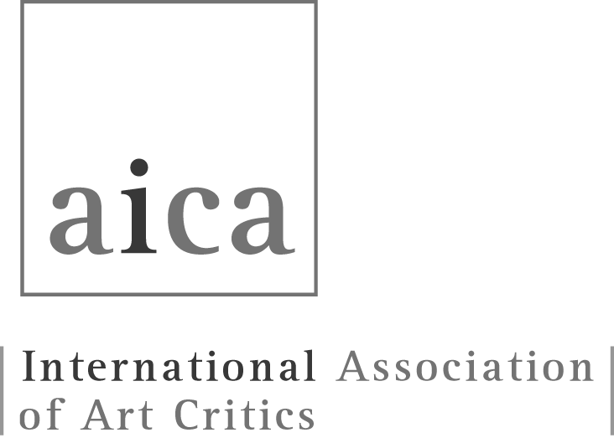

AICA MEMBERSHIP APPLICATION: BIOGRAPHICAL FORM

The application needs to be typewritten in one of AICA’s three official languages, English, French or Spanish. AICA International does not accept separate CVs, bibliographies and documents with the exception of applicants to the Open Section who need to provide supplementary information. Please note that all applications must be endorsed by the President of the relevant National Section or by two sponsors, in the case of applications for the Open Section.

Name of the National Section to be joined:

President of the National Section endorsing this application:

Names of two sponsors (Only for candidates to the Open Section):

Date of this application:

Applicant’s Surname:

First name:

Nationality:

Date (optional) and place of birth:

PRIVATE INFORMATION
Do you authorize the contact information below to be published in AICA's annual online Membership Directory, accessible only to the membership? Yes: No:

Home address:

Phone numbers:

Email:

Website:

PROFESSIONAL INFORMATION
Do you authorize your professional information below to be published in AICA's online Membership Directory, accessible only to the membership? Yes: No:

Institution/Organization/Publication for which you work:

Professional address:

Phone number(s):

Email:

Web:

Professional title(s) and qualification(s):

Please note that evidence must be given of continuous professional practice from at least the last three years

Media: print, broadcast, online
Please give title and dates:

1.

2.

3.

4.

5.

6.

7.

8.

9.

10.

Publication: books, catalogues, essays, papers
Please give the title, editor, publisher, year of publication, number of pages:

1.

2.

3.

4.

5.

6.

7.

8.

9.

10.

Teaching
Please give higher education institution, subject field, course(s) taught and dates:

1.

2.

3.

4.

5.

6.

7.

8.

9.

10.

Cultural Organisations: museums, galleries, government bodies, art agencies
Please give institution and your role/post and dates:

1.

2.

3.

4.

5.

6.

7.

8.

9.

10.

Curatorial
Please list exhibitions, projects, their venue(s), dates and publications:

1.

2.

3.

4.

5.

6.

7.

8.

9.

10.

For Official Use Only
AICA Electoral and Membership Committee (EMC)

Membership Application: Approved: Not Approved:
Date:

The Chair or other Representative of EMC:

Reasons for rejection:
1. Incomplete details in this Biographical Form to prove that the applicant undertook continuous professional practice during the last three years in any of the four areas stated in AICA Statutes Article 2.1 a-d:
2. The details provided were untrue or insufficient to meet the criteria for admission:

Action Required:
1. Return to Section President:
2. Return to Applicant (Open Section):
3. Applicant needs to amend data and resubmit a new Biographical Form:

Comments:

